Ex. No: 1 b SQL DML COMMANDS

**Date: 24/01/22**

**AIM:** To write SQL queries to execute different DML commands.

Data base created for this exercise is:

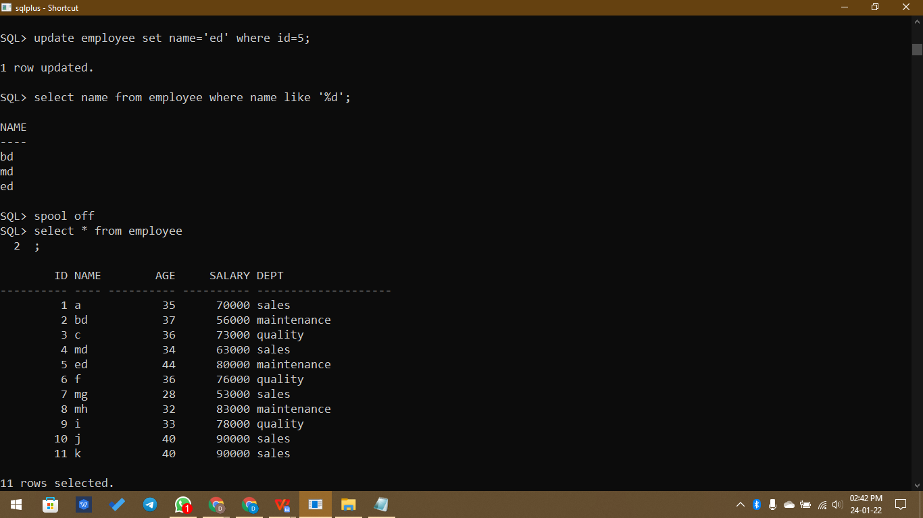

**DML Commands:**

* **Distinct-** Used to return distinct/unique values

**Syntax,**

**select distinct column_name from table_name;**

Example,

SQL> select distinct salary from employee;

SALARY

----------

76000

70000

56000

73000

63000

80000

53000

83000

78000

90000

* **min-** Used to find minimum value in a column

**Syntax,**

**select min(column_name) from table_name;**

Example,

SQL> select min(salary) from employee;

MIN(SALARY)

-----------

53000

* **max-** Used to find maximum value in a column

**Syntax,**

**select max(column_name) from table_name;**

Example,

SQL> select max(salary) from employee;

MAX(SALARY)

-----------

90000

* **fetch-** Used to find specific records

**Syntax,**

**select * from table_name fetch condition;**

Example,

SQL> select * from employee fetch first 4 rows only;

ID NAME AGE SALARY DEPT

---------- ---- ---------- ---------- --------------------

1 a 35 70000 sales

2 b 37 56000 maintenance

3 c 36 73000 quality

4 d 34 63000 sales

* **count-** Used to count number of records

**Syntax,**

**select count(column_name) from table_name;**

Example,

SQL> select count(id) from employee;

COUNT(ID)

----------

11

* **avg-** Used to find average value of a column

**Syntax,**

**select avg(column_name) from table_name;**

Example,

SQL> select avg(salary) from employee;

AVG(SALARY)

-----------

73818.1818

* **sum-** Used to find sum of a column

**Syntax,**

**select max(column_name) from table_name;**

Example,

SQL> select max(salary) from employee;

SUM(SALARY)

-----------

812000

* **between-** Used to find values between a range in a column

**Syntax,**

**select * from table_name where column_name between start point and end point;**

Example,

SQL> select * from employee where age between 30 and 35;

ID NAME AGE SALARY DEPT

---------- ---- ---------- ---------- --------------------

1 a 35 70000 sales

4 d 34 63000 sales

8 h 32 83000 maintenance

9 i 33 78000 quality

* **Not between-** Used to find values outside of a range in a column

**Syntax,**

**select * from table_name where column_name not between start point and end point;**

Example,

SQL> select * from employee where age not between 30 and 35;

ID NAME AGE SALARY DEPT

---------- ---- ---------- ---------- --------------------

2 b 37 56000 maintenance

3 c 36 73000 quality

5 e 44 80000 maintenance

6 f 36 76000 quality

7 g 28 53000 sales

10 j 40 90000 sales

11 k 40 90000 sales

* **Like -** Used to find records with starting or ending with something specific

**Syntax,**

**select column_name from table_name where column_name like 'm%';**

**select column_name from table_name where column_name like '%d';**

Example,

SQL> select name from employee where name like 'm%';

NAME

----

md

mg

mh

SQL> select name from employee where name like '%d';

NAME

----

bd

md

ed

SQL> create table employee(id int, name varchar(50), age int, salary int, dept varchar(20));

create table employee(id int, name varchar(50), age int, salary int, dept varchar(20))

*

ERROR at line 1:

ORA-00955: name is already used by an existing object

SQL> drop table employee

2 ;

Table dropped.

SQL> create table employee(id int, name varchar(50), age int, salary int, dept varchar(20));

Table created.

SQL> insert into employee values(1, 'a', 35, 70000, 'sales');

1 row created.

SQL> insert into employee values(2, 'b', 37, 56000, 'maintenance');

1 row created.

SQL> insert into employee values(3, 'c', 36, 73000, 'quality');

1 row created.

SQL> insert into employee values(4, 'd', 34, 63000, 'sales');

1 row created.

SQL> insert into employee values(5, 'e', 44, 80000, 'maintenance');

1 row created.

SQL> insert into employee values(6, 'f', 36, 76000, 'quality');

1 row created.

SQL> insert into employee values(7, 'g', 28, 53000, 'sales');

1 row created.

SQL> insert into employee values(8, 'h', 32, 83000, 'maintenance');

1 row created.

SQL> insert into employee values(9, 'i', 33, 78000, 'quality');

1 row created.

SQL> insert into employee values(10, 'j', 40, 90000, 'sales');

1 row created.

SQL> select * from employee;

ID NAME AGE

---------- -------------------------------------------------- ----------

SALARY DEPT

---------- --------------------

1 a 35

70000 sales

2 b 37

56000 maintenance

3 c 36

73000 quality

ID NAME AGE

---------- -------------------------------------------------- ----------

SALARY DEPT

---------- --------------------

4 d 34

63000 sales

5 e 44

80000 maintenance

6 f 36

76000 quality

ID NAME AGE

---------- -------------------------------------------------- ----------

SALARY DEPT

---------- --------------------

7 g 28

53000 sales

8 h 32

83000 maintenance

9 i 33

78000 quality

ID NAME AGE

---------- -------------------------------------------------- ----------

SALARY DEPT

---------- --------------------

10 j 40

90000 sales

10 rows selected.

SQL> alter table employee modify name varchar(2);

Table altered.

SQL> select * from employee;

ID NA AGE SALARY DEPT

---------- -- ---------- ---------- --------------------

1 a 35 70000 sales

2 b 37 56000 maintenance

3 c 36 73000 quality

4 d 34 63000 sales

5 e 44 80000 maintenance

6 f 36 76000 quality

7 g 28 53000 sales

8 h 32 83000 maintenance

9 i 33 78000 quality

10 j 40 90000 sales

10 rows selected.

SQL> alter table employee modify name varchar(4);

Table altered.

SQL> select * from employee;

ID NAME AGE SALARY DEPT

---------- ---- ---------- ---------- --------------------

1 a 35 70000 sales

2 b 37 56000 maintenance

3 c 36 73000 quality

4 d 34 63000 sales

5 e 44 80000 maintenance

6 f 36 76000 quality

7 g 28 53000 sales

8 h 32 83000 maintenance

9 i 33 78000 quality

10 j 40 90000 sales

10 rows selected.

SQL> select distinct salary from employee;

SALARY

----------

76000

70000

56000

73000

63000

80000

53000

83000

78000

90000

10 rows selected.

SQL> insert into employee values(11, 'k', 40, 90000, 'sales');

1 row created.

SQL> select * from employee;

ID NAME AGE SALARY DEPT

---------- ---- ---------- ---------- --------------------

1 a 35 70000 sales

2 b 37 56000 maintenance

3 c 36 73000 quality

4 d 34 63000 sales

5 e 44 80000 maintenance

6 f 36 76000 quality

7 g 28 53000 sales

8 h 32 83000 maintenance

9 i 33 78000 quality

10 j 40 90000 sales

11 k 40 90000 sales

11 rows selected.

SQL> select distinct salary from employee;

SALARY

----------

76000

70000

56000

73000

63000

80000

53000

83000

78000

90000

10 rows selected.

SQL> select min(salary) from employee;

MIN(SALARY)

-----------

53000

SQL> select max(salary) from employee;

MAX(SALARY)

-----------

90000

SQL> select * from employee fetch first 4 rows only;

ID NAME AGE SALARY DEPT

---------- ---- ---------- ---------- --------------------

1 a 35 70000 sales

2 b 37 56000 maintenance

3 c 36 73000 quality

4 d 34 63000 sales

SQL> select count(id) from employee;

COUNT(ID)

----------

11

SQL> select avg(salary) from employee;

AVG(SALARY)

-----------

73818.1818

SQL> select sum(salary) from employee;

SUM(SALARY)

-----------

812000

SQL> select * from employee where age between 30 and 35;

ID NAME AGE SALARY DEPT

---------- ---- ---------- ---------- --------------------

1 a 35 70000 sales

4 d 34 63000 sales

8 h 32 83000 maintenance

9 i 33 78000 quality

SQL> select * from employee where age not between 30 and 35;

ID NAME AGE SALARY DEPT

---------- ---- ---------- ---------- --------------------

2 b 37 56000 maintenance

3 c 36 73000 quality

5 e 44 80000 maintenance

6 f 36 76000 quality

7 g 28 53000 sales

10 j 40 90000 sales

11 k 40 90000 sales

7 rows selected.

SQL> update employee set name='md' where id=4;

1 row updated.

SQL> update employee set name='mh' where id=8;

1 row updated.

SQL> update employee set name='mg' where id=7;

1 row updated.

SQL> select names from employee where name like 'm%';

select names from employee where name like 'm%'

*

ERROR at line 1:

ORA-00904: "NAMES": invalid identifier

SQL> select name from employee where name like 'm%';

NAME

----

md

mg

mh

SQL> update employee set name='bd' where id=2;

1 row updated.

SQL> update employee set name='ed' where id=5;

1 row updated.

SQL> select name from employee where name like '%d';

NAME

----

bd

md

ed

SQL> spool off

**Result:**

Thus the DML commands are used to modify or manipulate data records present in the customer database tables.